### **ASSIGNMENT OF PHP 7 and Design patterns**

**1)Upgrade PHP version to PHP 7.4**

**ANSWER 1:**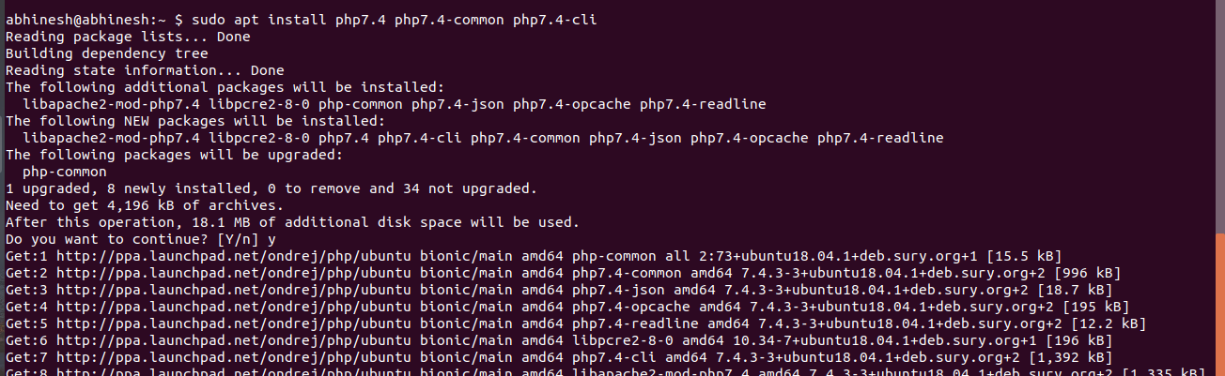

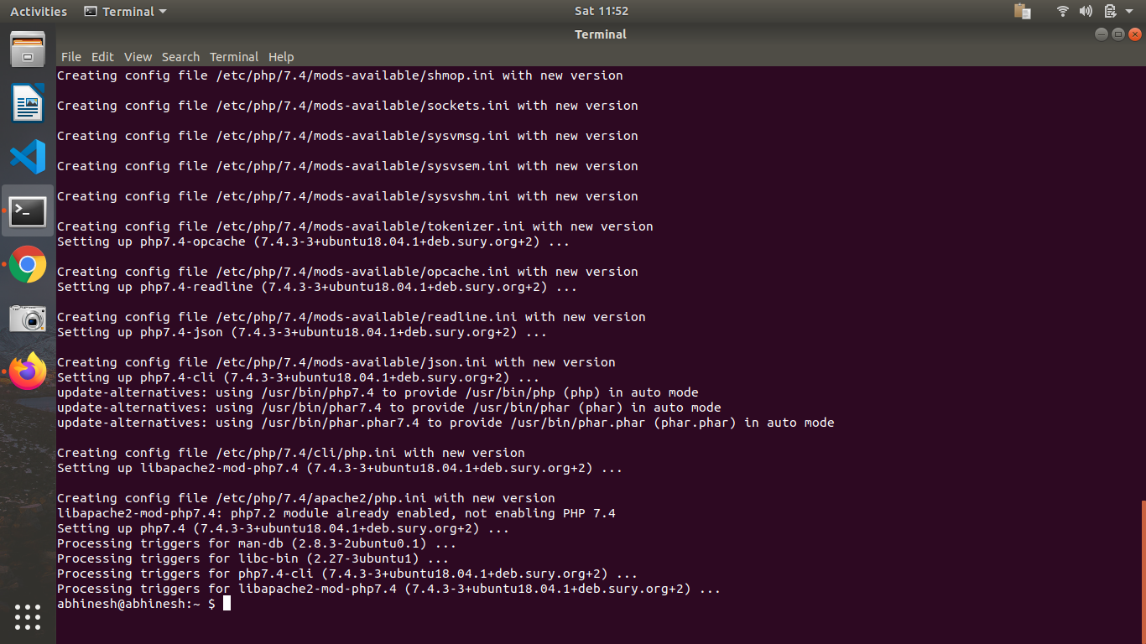

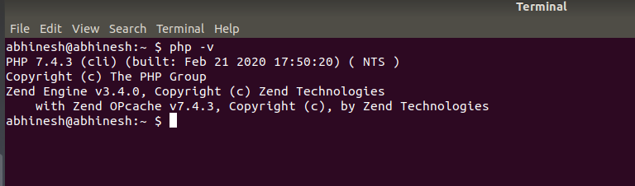**2) What are the advantages of spread operator over array_merge in PHP?**

**ANSWER 2:**An array pair prefixed by … will be expanded in places during array definition. Only arrays and objects who implement Traversable can be expanded.It's possible to do the expansion multiple times, and unlike argument unpacking, … can be used anywhere. It's possible to add normal elements before or after the spread operator.

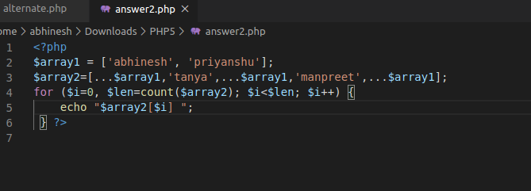

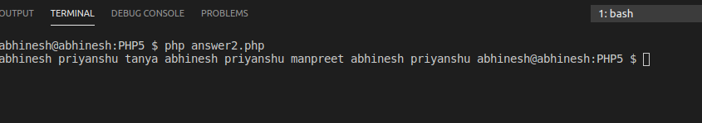

**3)Write the output of these;**

**$arr1 = [1, 2, 3];**

**$arr2 = [...$arr1];**

**$arr3 = [0, ...$arr1];**

**$arr4 =****array(...$arr1, ...$arr2, 111);**

**what will be the output of $arr2, $arr3, $arr4.**

**ANSWER 3:**

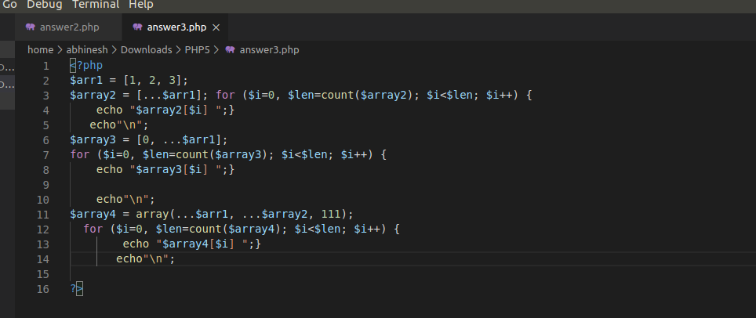

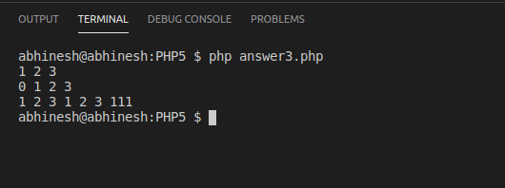

**4)Write a program to print an array in which output is returned by function using the spread operator.**

**ANSWER 4:**

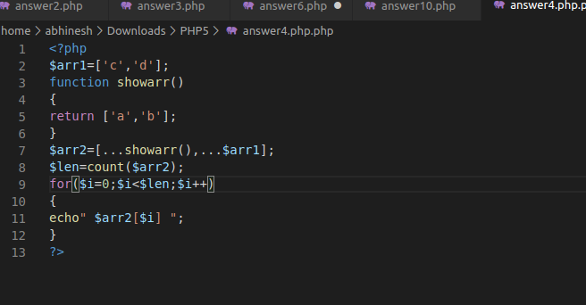

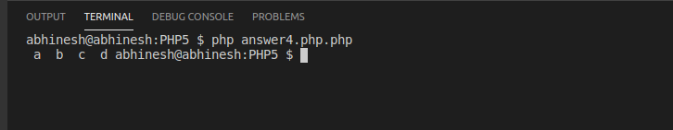

**5) What is dependency Injection?**

**ANSWER 5:**Dependency injection is a procedure where one object supplies the dependencies of another object. Dependency Injection is a software design approach that allows avoiding hard-coding dependencies and makes it possible to change the dependencies both at runtime and compile time.

## **Constructor Injection:**

In this approach, we can inject an object through the class constructor.

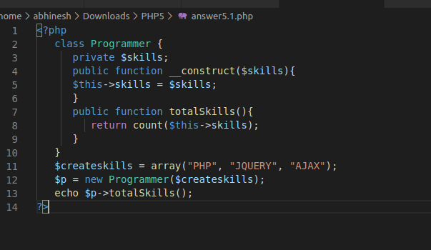

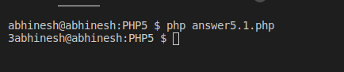

## **Setter Injection:**

where you inject the object to your class through a setter function.

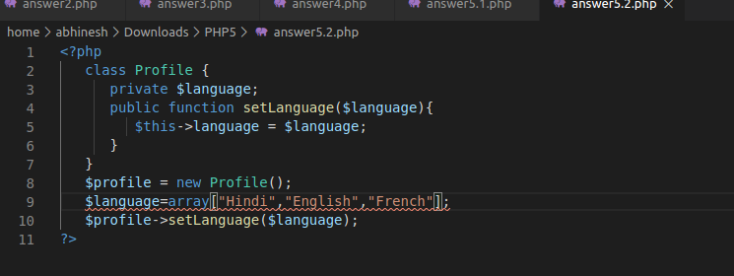

**6)Write an example of a factory class where we pass 4 different car models and it returns price and builds year of the car.**

**ANSWER 6:**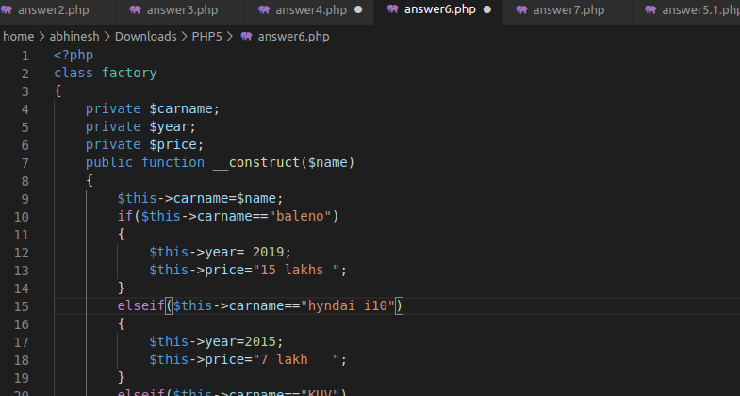

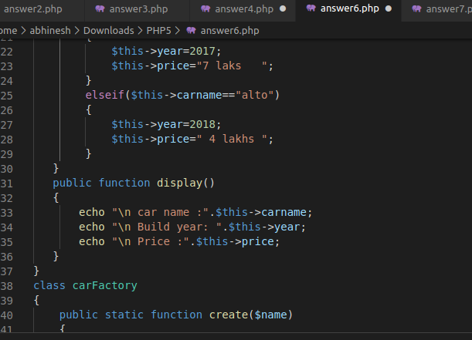

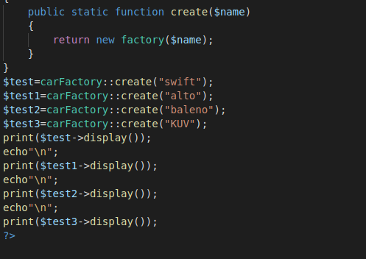

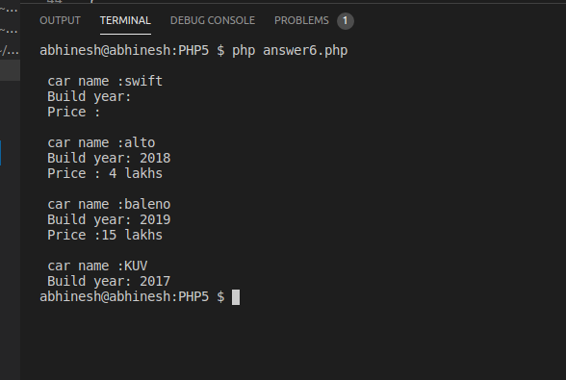

**7)Give an example of singleton class.**

**ANSWER 7:**Singleton is the design patterns in PHP OOPs concept that is a special kind of class that can be instantiated only once. If the object of that class is already instantiated then, instead of creating a new one, it gets returned.

The major reason to use the Singleton Design Pattern is that we can use the Singleton Design Pattern object globally and unlike other normal classes, it could only contain one kind of object or one kind of instance. Sometimes, when there is an object that is created only once like the DataBase connection, then the use of Singleton is much more preferable. But note that the constructor method needs to be in private to make the class Singleton.

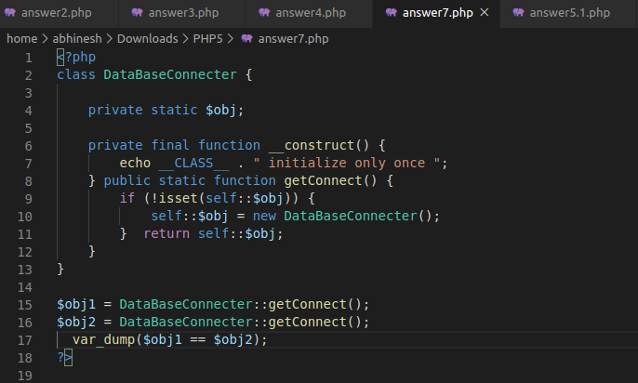

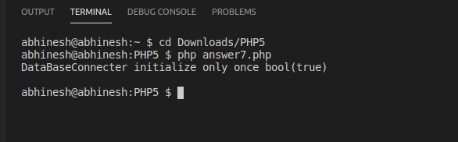

**8)What are the benefits of following design patterns?**

**ANSWER 8:**

1. They are reusable in multiple projects.
2. They provide the solutions that help to define the system architecture.
3. They capture the software engineering experiences.
4. They provide transparency to the design of an application.
5. They are well-proved and testified solutions since they have been built upon the knowledge and experience of expert software developers.
6. Design patterns don't guarantee an absolute solution to a problem. They provide clarity to the system architecture and the possibility of building a better system.

**9)Define a class with type properties.**

**ANSWER 9**

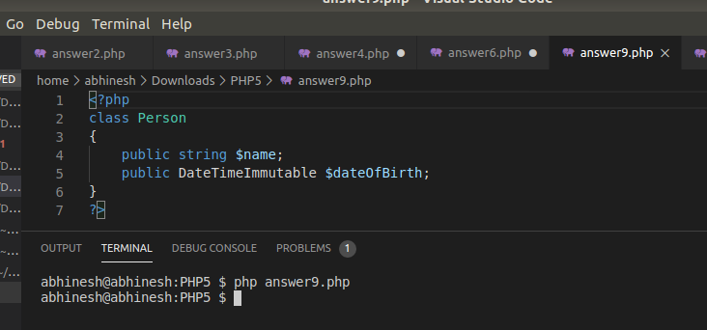

**10)Write a function using arrow function array_map.**

**ANSWER 10:**

